**EVENTBRITE – SEMINARS, CONFERENCES, PRESENTATIONS, WORKSHOPS AND LECTURES.**

Through my EVENTBRITE page, I have organized over 50 events to be attended by an estimated 3000 participants over the coming weeks and months.

Here is my EVENTBRITE page <https://www.eventbrite.co.uk/o/artificial-intelligence-consulting-59435163063>

|  |
| --- |
| **Artificial Intelligence for Teachers and Educators** |
| |  | | --- | |  | |
| **Artificial Intelligence for Teachers and Educators** |

**Saturday, 31 May 2025 from 04:00 to 06:00 (United Kingdom Time)**

[[](https://www.eventbrite.co.uk/e/use-artificial-intelligence-in-proof-reading-spelling-and-grammar-check-tickets-1030534826407?aff=ebdsoporgprofile)](https://www.eventbrite.co.uk/e/use-artificial-intelligence-in-proof-reading-spelling-and-grammar-check-tickets-1030534826407?aff=ebdsoporgprofile" \t "_blank)

### Use Artificial Intelligence in Proof Reading: Spelling and Grammar Check Wed, 6 Nov, 15:00 GMT

[[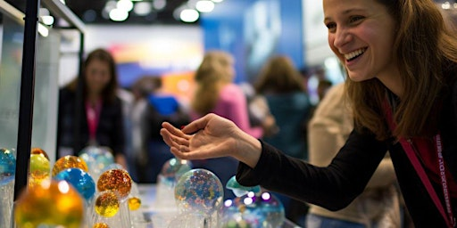](https://www.eventbrite.co.uk/e/using-artificial-intelligence-in-qualitative-and-qualitative-analysis-tickets-1034814697617?aff=ebdsoporgprofile)](https://www.eventbrite.co.uk/e/using-artificial-intelligence-in-qualitative-and-qualitative-analysis-tickets-1034814697617?aff=ebdsoporgprofile" \t "_blank)

### Using Artificial Intelligence in Qualitative and Qualitative Analysis Sat, 9 Nov, 10:00 GMT

[[](https://www.eventbrite.co.uk/e/using-artificial-intelligence-in-regression-analysis-tickets-1034812410777?aff=ebdsoporgprofile)](https://www.eventbrite.co.uk/e/using-artificial-intelligence-in-regression-analysis-tickets-1034812410777?aff=ebdsoporgprofile" \t "_blank)

### Using Artificial Intelligence in Regression Analysis Sun, 10 Nov, 10:00 GMT

[[](https://www.eventbrite.co.uk/e/using-artificial-intelligence-in-descriptive-analysis-tickets-1034808850127?aff=ebdsoporgprofile)](https://www.eventbrite.co.uk/e/using-artificial-intelligence-in-descriptive-analysis-tickets-1034808850127?aff=ebdsoporgprofile" \t "_blank)

### Using Artificial Intelligence in Descriptive Analysis Sun, 10 Nov, 13:00 GMT

[[](https://www.eventbrite.co.uk/e/artificial-intelligence-for-content-creators-tickets-1039003025017?aff=ebdsoporgprofile)](https://www.eventbrite.co.uk/e/artificial-intelligence-for-content-creators-tickets-1039003025017?aff=ebdsoporgprofile" \t "_blank)

### Artificial Intelligence for Content Creators Wed, 13 Nov, 13:00 GMT

[[](https://www.eventbrite.co.uk/e/artificial-intelligence-in-cronbach-testing-tickets-1034808027667?aff=ebdsoporgprofile)](https://www.eventbrite.co.uk/e/artificial-intelligence-in-cronbach-testing-tickets-1034808027667?aff=ebdsoporgprofile" \t "_blank)

### Artificial Intelligence in Cronbach testing

Sat, 23 Nov, 10:00 GMT

[[](https://www.eventbrite.co.uk/e/the-use-of-artificial-intelligence-in-research-questionnaire-quality-check-tickets-1034807335597?aff=ebdsoporgprofile)](https://www.eventbrite.co.uk/e/the-use-of-artificial-intelligence-in-research-questionnaire-quality-check-tickets-1034807335597?aff=ebdsoporgprofile" \t "_blank)

### The Use of Artificial Intelligence in Research Questionnaire Quality Check Sat, 30 Nov, 10:00 GMT

[[](https://www.eventbrite.co.uk/e/the-use-of-artificial-intelligence-in-conducting-research-tickets-1008610439977?aff=ebdsoporgprofile)](https://www.eventbrite.co.uk/e/the-use-of-artificial-intelligence-in-conducting-research-tickets-1008610439977?aff=ebdsoporgprofile" \t "_blank)

### The use of Artificial Intelligence in Conducting Research Fri, 31 Jan, 10:00 GMT

[[](https://www.eventbrite.co.uk/e/writing-business-plan-using-artificial-intelligence-tickets-1039293945167?aff=ebdsoporgprofile)](https://www.eventbrite.co.uk/e/writing-business-plan-using-artificial-intelligence-tickets-1039293945167?aff=ebdsoporgprofile" \t "_blank)

### Writing Business Plan Using Artificial Intelligence Sat, 1 Mar, 11:00 GMT

[[](https://www.eventbrite.co.uk/e/data-collection-using-artificial-intelligence-tickets-1024294150377?aff=ebdsoporgprofile)](https://www.eventbrite.co.uk/e/data-collection-using-artificial-intelligence-tickets-1024294150377?aff=ebdsoporgprofile" \t "_blank)

### Data Collection Using Artificial Intelligence Sat, 1 Mar, 16:00 GMT

[[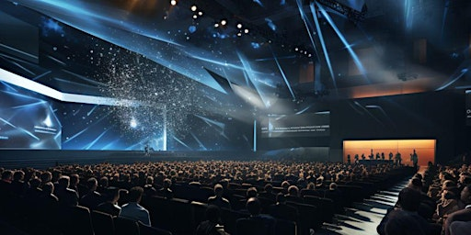](https://www.eventbrite.co.uk/e/using-artificial-intelligence-for-editorial-purposes-tickets-1039017327797?aff=ebdsoporgprofile)](https://www.eventbrite.co.uk/e/using-artificial-intelligence-for-editorial-purposes-tickets-1039017327797?aff=ebdsoporgprofile" \t "_blank)

### Using Artificial Intelligence for Editorial Purposes Sat, 8 Mar, 16:03 GMT

[[](https://www.eventbrite.co.uk/e/designing-data-collection-tools-and-instruments-using-artificial-intelligence-tickets-1024291352007?aff=ebdsoporgprofile)](https://www.eventbrite.co.uk/e/designing-data-collection-tools-and-instruments-using-artificial-intelligence-tickets-1024291352007?aff=ebdsoporgprofile" \t "_blank)

### Designing Data Collection Tools and Instruments using Artificial Intelligence Sat, 8 Mar, 17:00 GMT

[[](https://www.eventbrite.co.uk/e/use-artificial-intelligence-to-write-job-descriptions-and-person-specifications-tickets-1039298438607?aff=ebdsoporgprofile)](https://www.eventbrite.co.uk/e/use-artificial-intelligence-to-write-job-descriptions-and-person-specifications-tickets-1039298438607?aff=ebdsoporgprofile" \t "_blank)

### Use Artificial Intelligence to write Job Descriptions and, Person Specifications Sat, 15 Mar, 10:00 GMT